Logistics Plan – HTS-12 Turbine Components
Harrow Bay Offshore Wind · Aarhus/Esbjerg → Port of Eastholm
Elena Márquez · 21 September 2026 · HB-LOG-PLN-0002

1. Purpose
This plan describes how the components of the 40 Halden HTS-12 turbines for Harrow Bay travel from the Halden factories in Aarhus and Esbjerg to the Port of Eastholm, how they are stored and pre-assembled, and how the logistics interface with the installation campaign starting on 1 March 2027. It is agreed with Halden Turbine Systems (Lars Henriksen) under contract WE-CON-2025-022.

2. Components per turbine set
Component | Qty | Dimensions | Weight (t) | Origin
Nacelle incl. hub | 1 | 22 × 10 × 11 m | 520 | Aarhus
Blades | 3 | 115 m | 54 each | Esbjerg
Tower sections | 4 | Ø 7.0 m, 26–34 m | 95–180 | Aarhus (sub-supplier)
Transformer / converter module | 1 | in tower base | 48 | Aarhus
Bolts and small parts | 2 containers | 20 ft | 14 | Aarhus

3. Transport
- Sea transport on two dedicated feeder vessels (roll-on/lift-off), each carrying 2 complete turbine sets
- Delivery term DAP Port of Eastholm, Quay 3 (Incoterms 2020) – risk passes on unloading
- Transit time Aarhus – Eastholm: 2.5 days; weather limit for loading Beaufort 6
- Marine warranty surveyor approval of sea-fastening for every voyage

4. Delivery schedule
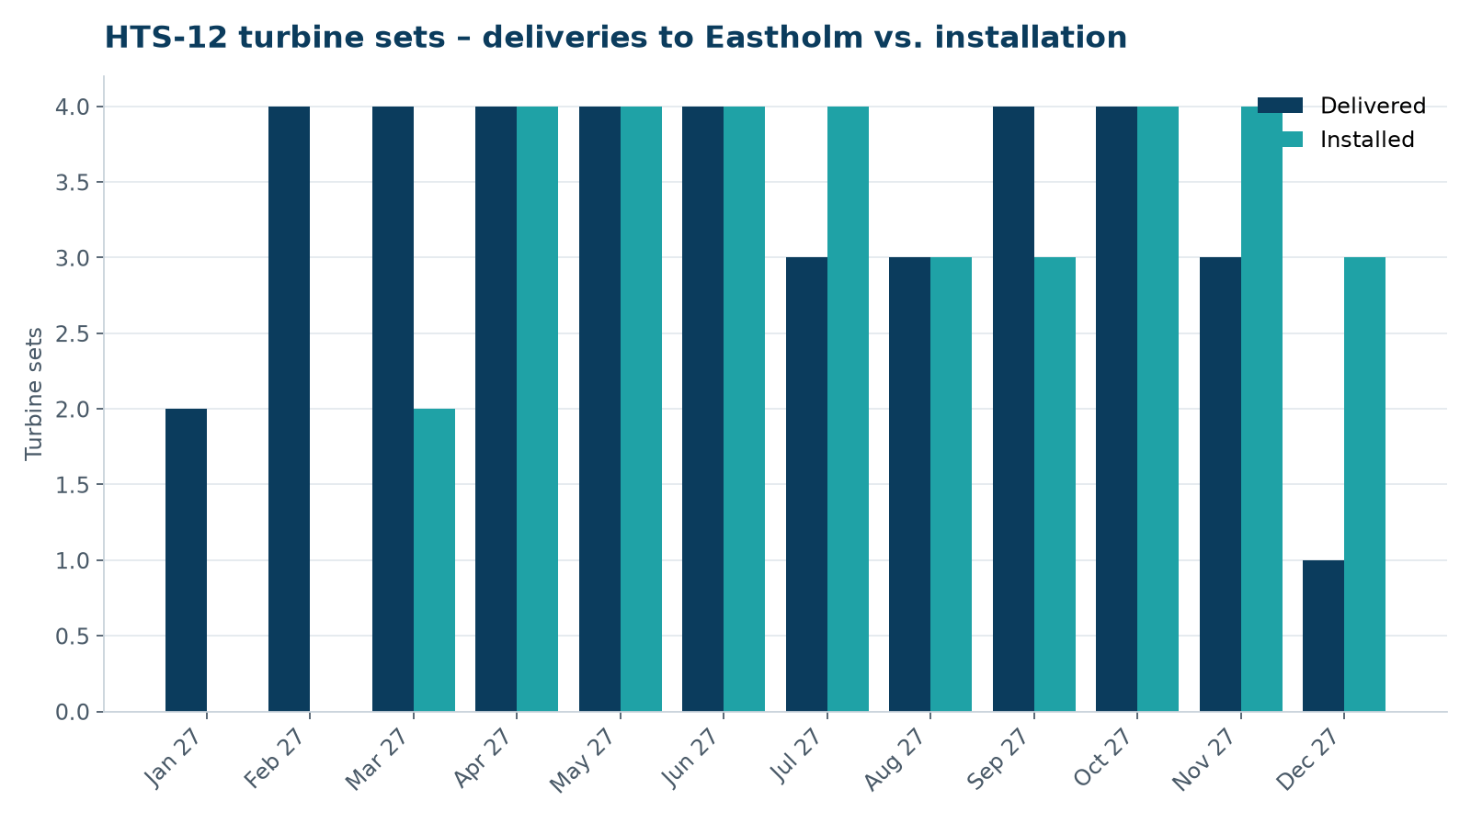
Figure 1 – Planned deliveries and installation of turbine sets 2027
Deliveries start in January 2027 to build a buffer of six sets before the first installation on 1 March 2027. The buffer is limited by the storage capacity on Quay 3 (eight sets) and is kept at four to six sets during the campaign.

5. Storage and pre-assembly at Port of Eastholm
Area | Use | Capacity
Quay 3 – Area C | Tower pre-assembly (2 sections stacked) | 8 sets
Quay 2 – Area A | Blade racks (from Feb 2027, after monopiles) | 30 blades
Quay 3 – load-out berth | Installation vessel loading | 4 sets per trip

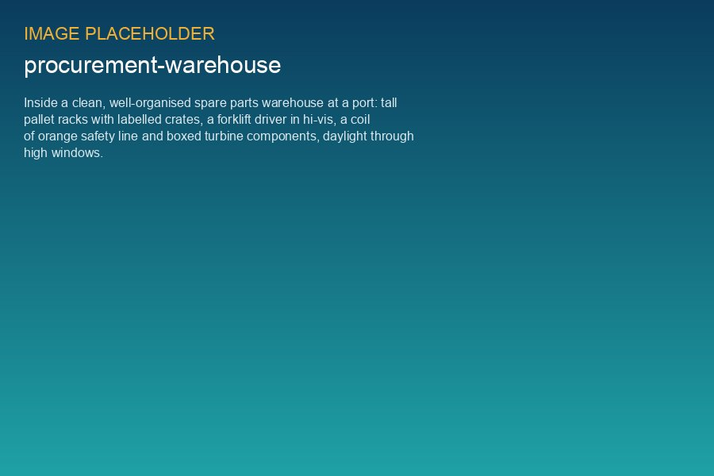
Spare parts warehouse Quay 3 – handed over in September 2026

6. Interfaces and risks
- Monopile campaign must free Quay 2 Area A by 31 January 2027 (see HB-RISK-013 and HB-RISK-029)
- 1,350 t crawler crane reserved under framework FA-2026-01 from 11 January 2027
- Customs: components from Denmark to the UK require customs clearance – Halden as exporter, Weyland UK project company as importer of record; duty relief under the UK Global Tariff for wind turbine parts confirmed
- Severn export cable 2 delay (HB-RISK-017) does not affect turbine logistics

